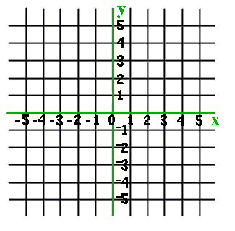
Complete the X-Y chart for each equation. Plot the points and graph the lines.
1. y= x + 1
x | y
0
2
 | 4

2. x+y=5
x | y
0
1
2

Write an equation in slope-intercept form for each slope (m) and y-intercept (b). y=mx+b
3. y-intercept of 2, slope of – ½ equation__________________________________
4. y-intercept of 0, slope of ¼ equation__________________________________
5. y-intercept of -4, slope of 2 equation__________________________________

