acute | obtuse | right

1.____________________ 2.__________ ___________ 3.___________________
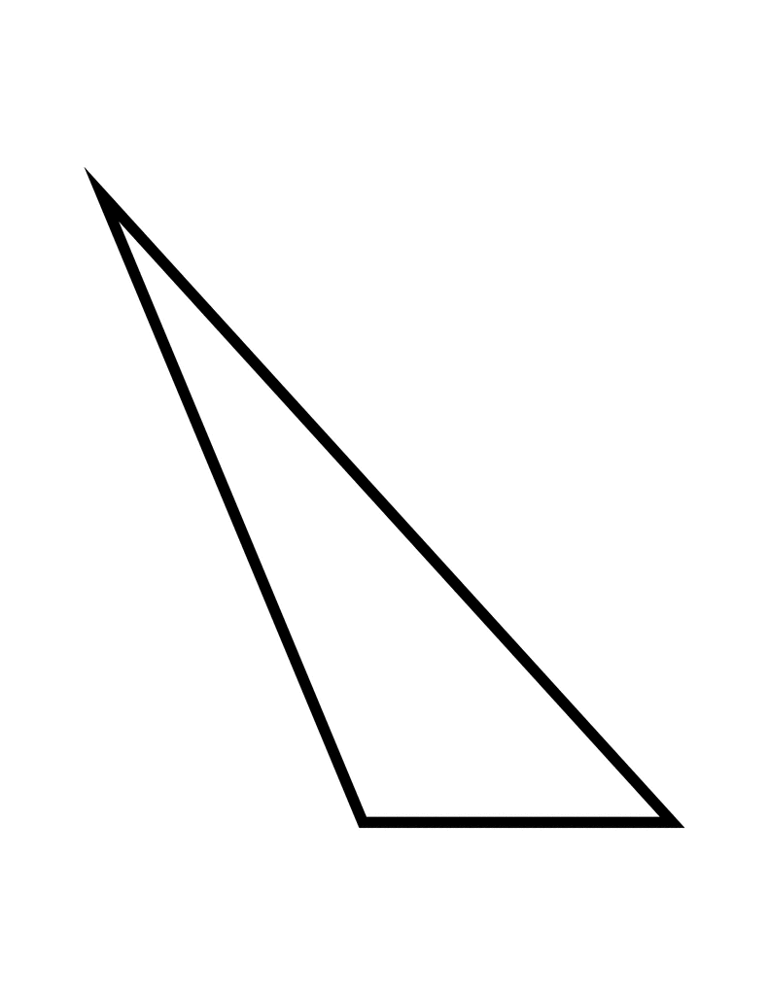
_____________________________________________________________________________________
scalene | isosceles | equilateral

4.______________________ 5.______________________ 6._____________________

_____________________________________________________________________________________
True or False
___________7. All obtuse triangles have two acute angles.
___________8. The sum of the interior angles of a triangle equals 360 degrees.
___________9. A right triangle cannot be a scalene triangle.
___________10. An equilateral triangle is also equiangular.

