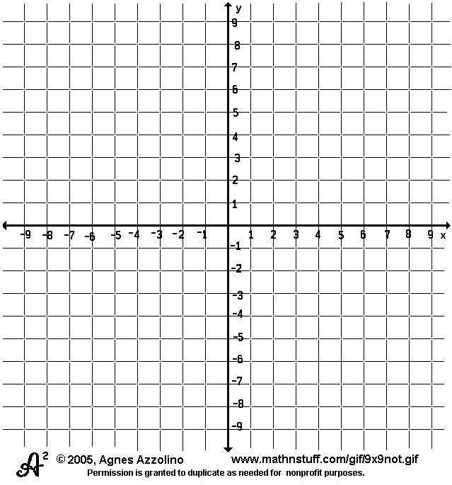
1. Reflect trapezoid ABCD across the
y-axis. Label trapezoid A’B’C’D’.
List the coordinates of the prime
points below.

A’ ( )

B’ ( )

C’ ( )

D’ ( )

2. Dilate triangle GHI by a
scale factor of 2.
Label triangle G’H’I’. List the
coordinates of the prime points
below.

G’ ( )

H’ ( )

I’ ( )

3. What are the differences between similar and congruent figures?

