Directions: Circle the best answer or answers. Write the letter(s) on the line provided.
_____1. A. reflection
B. rotation
C. dilation
D. translation

_____2. A. reflection
B. rotation
C. dilation
D. translation

_____3. A. reflection
B. rotation
C. dilation
D. translation
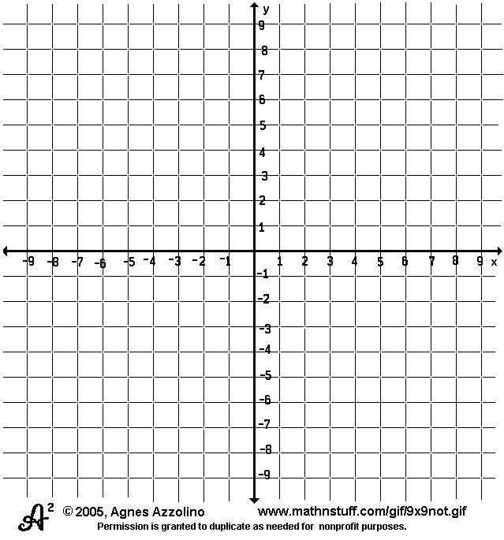
.
4. Dilate rectangle ABCD by a scale
factor of 2. List the new
coordinates.

A’ ( )

B’ ( )

C’ ( )

D’( )

