Systems of Equations: Which restaurant would you eat at? 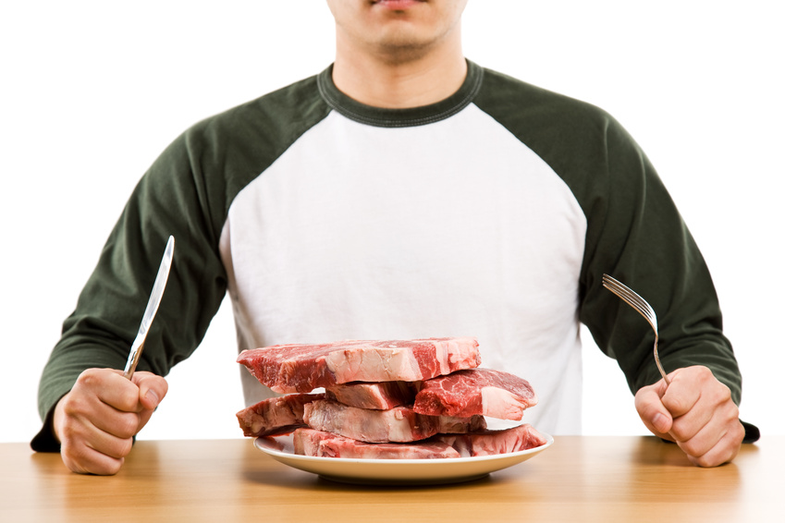

Golden Corral charges $11 for a buffet plus $1 for each drink. Western Sizzlin charges $9 for a buffet plus $2 for each drink. Which restaurant has the best deal? (I made up these prices!!) **Make sure to copy this question onto your poster**

- Write 2 equations to represent the 2 restaurants. Predict if these equations will be linear of nonlinear (how do you know?). If they are linear will the lines point upward or downward (how do you know?).

- Graph the system of equations. (Show your x/y tables) **Use a ruler or your answer will not come out correctly**

- What is the point of intersection on your graph? What does this mean?

- Verify that the intersection point show in your graph is a solution for both equations.

- Which restaurant would you go to? Why?

**If you have time decorate your poster- remember this problem is about restaurants!**

