Complete the X-Y charts for each equation. Plot the points and graph two lines, or use the slope and y-intercept to graph the line.
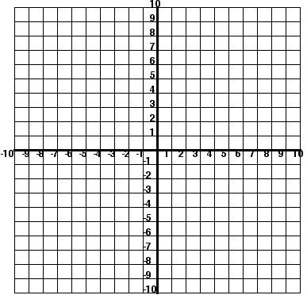
1. y= ½ x + 6
x | y
0
2
4

y=x-2
x | y
0
2
8

At what point do the lines intersect?_________________
2. Two equations are graphed on the coordinate plane below.
At what point, do the lines
intersect?_____________

If the point of intersection
is the solution for this system
of equations, what is the solution?_____________

____4. The point at which a line intersects the y-axis is called the………
A. slope B. x-intercept C. y-intercept

____5. All of the following describe slope EXCEPT……..
A. y-intercept B. steepness of a line C. rise/run

