1. Circle the equation that is NOT written in 6. Graph: y=2x+1
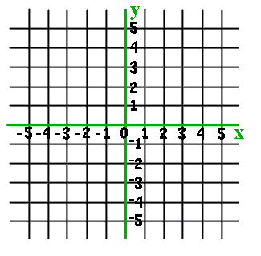
slope-intercept form.

A. 2x + 4y = 24
B. y = ¾ x
C. y = 12 – 2x

2. In y= ½ x+8, what is the slope?

A. ½
B. 8
C. -8

3. In y= ½ x-4, what is the y-intercept?

A. ½
B. 4
C. -4
7. Graph: -3/2x +3
4. Which equation has a slope of – ½ and a
y-intercept of 3?

A. y= -¼ x+3
B. y= 3x-½
C. y=- ½x +3

5. Graph: y=1/3x-5

My Score: ______correct out of 7

