1.2 x 10⁹ 3.456 x 10⁻⁷ 7.51 x 10¹⁸
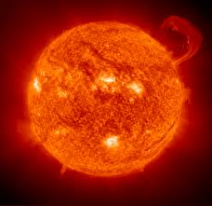
What is the purpose of scientific notation?____________________________________________________
_____________________________________________________________
_____________________________________________________________
_____________________________________________________________
_____________________________________________________________
The sun is 92,960,000 miles away from Earth.

