Label each example **UNIVARIATE** or **BIVARIATE**.

1. weight of newborn babies born at Aultman ________

2. GPA and number of days absent___________

3. scores on Mrs. R's volume test____________

4. daily temperature and cost of AC___________

5. favorite color____________

Label each pair of variables as **POSITIVE, NEGATIVE,** or **NO** relationship.

___________6. Length of a taxi ride and the amount of the fare

___________7. Driving speed and driving time

___________8. Hair color and weight

___________9. Outside temperature and cost of air conditioning

___________10. A child’s age and a child’s height

Label each scatter plot as showing a **POSITIVE, NEGATIVE,** or **NO** relationship.



________________ ________________ _______________



_______________ ________________ _______________

Circle the outlier on each scatter plot.

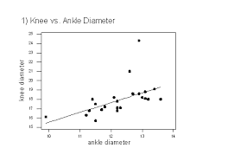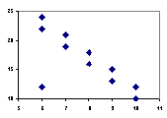

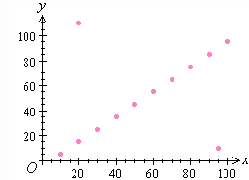

Approximate a line of best fit. Draw a line of best fit on each scatter plot.

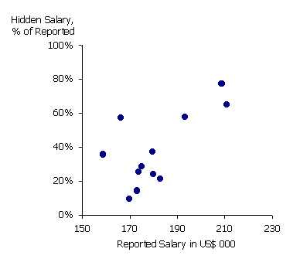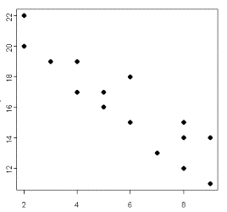

1. Identify two variables between which there would be a positive association.

_________________________________________________________________

2. Identify two variables between which there would be no association.

_________________________________________________________________

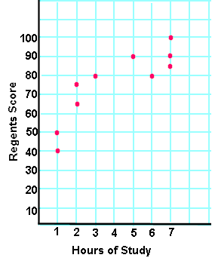

Draw a line of best fit. Use it to make a prediction. If a student spends 4 hours studying, predict what her score will be on the Regents exam.