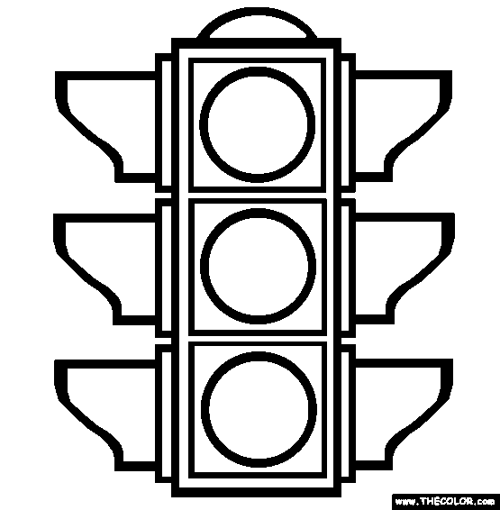

Traffic Light Ticket Traffic Light Ticket

