Complete the X-Y charts for each equation. Plot the points and graph two lines, or use the slope and y-intercept to graph the line.
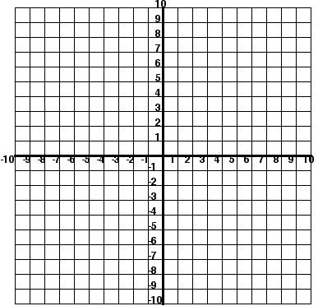
1. y= 2 x -1
x | y
0
1
2

y=x+1
x | y
0
2
8

At what point do the lines intersect?_________________
2. 3.

What is the solution?_____________ What is the solution?______________
4. What kind of lines will have one solution?______________________________

5. 1,245 6. 48 7. 567 8. ½ + ½ =
-647 x24 +258

9. Austin babysits for his neighbor. He gets paid $4 an hour. Write an equation to calculate his total pay for one week if he works up to 15 hours. Define the two variables. Create a graph showing his total pay for hours worked.
a. What are your variables?
__=_____________________________
__=_____________________________
b. Write an equation using both variables and the information given in the problem.
____________________=____
c. Make an input/output chart for your two variables.
equation____________________

d. Graph your data.

