Complete the X-Y charts for each equation. Plot the points and graph two lines, or use the slope and y-intercept to graph the line.
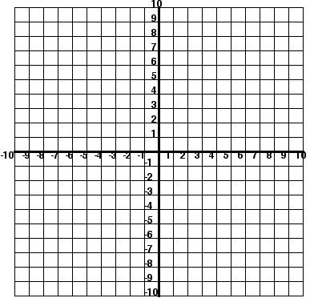
1. y= ¼ x + 2
x | y
0
4
12

y=x-1
x | y
0
2
8

At what point do the lines intersect?_________________
2. 3.

How many solutions?_____________ How many solutions?______________
4. What kind of lines will have an infinite number of solutions?______________________________

