Resource Math 8 Name_____________________________________________Date__________Per_____
Unit Solving Systems of Linear Equations Graphically
** Solve for y FIRST**
- Solve Graphically  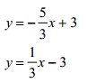 | 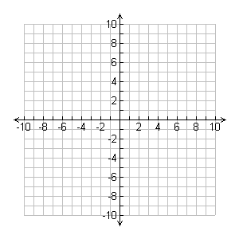
2)
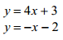

- Solve graphically
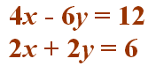
- Solve Graphically
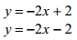
- Solve graphically
