A. B. C.
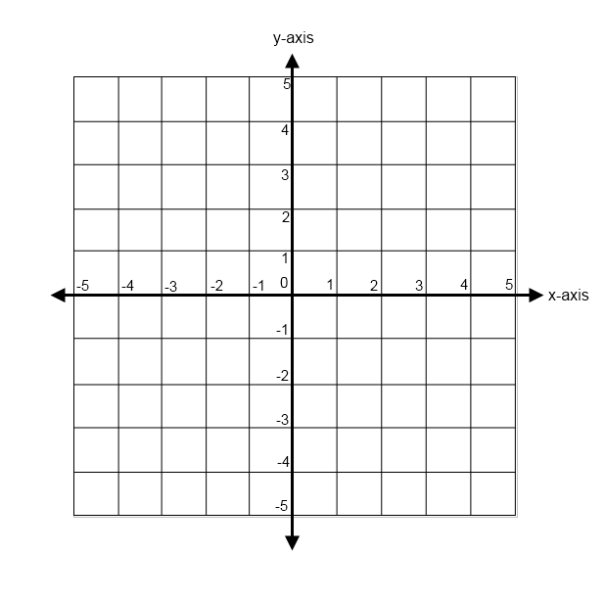
____1. Which line has no slope?

____2. Which line has an undefined slope?

____3. Which line has a slope of 2/3?

____4. What is the x-intercept of line A?

____5. What is the y-intercept of line A?

Calculate the slope using rise . Circle the best answer.
run
7. Which equation has no solution?
6.
a. 2x+3=16
b. y-2=y-2
c. 2m-3=2m+6

8. How many solutions does x-6=x-6 have?
a. one b. none c. infinite

9. Name one real-world example of a negative m=_______________________ slope.________________________________
Turn the page.
A.
B.
C.
____10. Which line has a negative slope?

____11. Which line has a positive slope?

____12. Which line has an undefined slope?

My score was ______out of 12.

