y=mx+b where m=slope and b=y-intercept

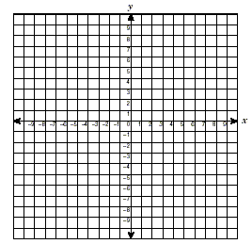
slope=______________________
y-intercept=_________________
equation____________________

slope=______________________
y-intercept=_________________
equation____________________

m=________________________
b=_________________________
equation____________________

m=_______________________
b=________________________
equation___________________

y=mx+b where m=slope and b=y-intercept

