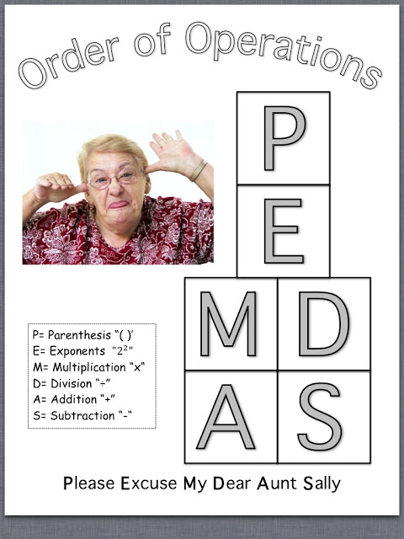



 



If you need more practice with order of operations, there are fun games online.

<http://www.math-play.com/Order-of-Operations-Millionaire/order-of-operations-millionaire.html>

<http://mrnussbaum.com/orderops/>

http://www.softschools.com/math/order_of_operations/games/