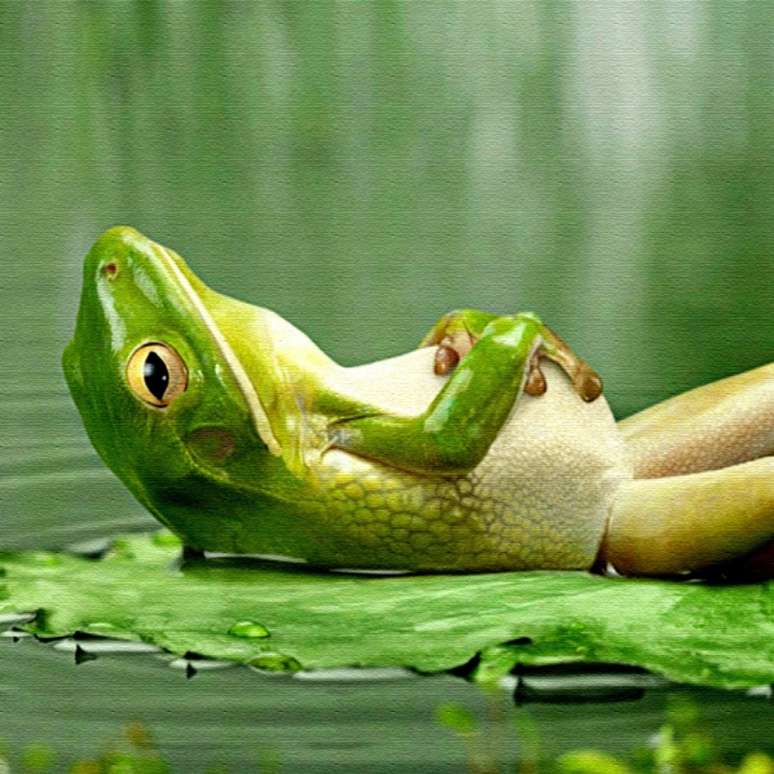
Some frogs, dragonflies, and turtles were sitting around the pond. There were a total of 122 frogs, dragonflies, and turtles. There were 4 times as many dragonflies as there were frogs. There are 22 turtles. There are 2 less turtles than frogs. How many frogs are around the pond? How many dragonflies?

