|  |  |  |  |
| --- | --- | --- | --- |
| positive | negative | undefined | zero |



1. ______________ 2._______________ 3._______________ 4.________________

**Calculate** the slope using **rise** . **Circle** the best answer.

 **run**

6. Which equation has no solution?

5.

a. 2x+3=16

b. x=x

c. m-3=m+6

7. How many solutions does 2x+1=2x+1 have?

a. one b. none c. infinite

m=______________

8.  9. Name one real-world example of a negative slope.________________________________

_____________________________________

10. Name one real-world example of a positive slope.______________________________ ___________________________________

m=_____________

11. Circle the best definition of slope.

A. the direction of a line B. the steepness of a line C. the direction and steepness of a line

**A. B. C.**

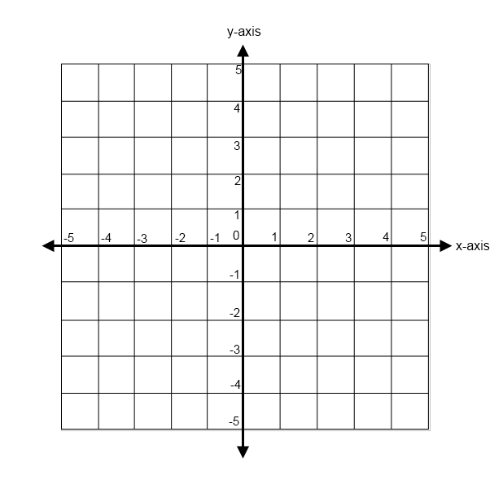

____12. Which line has the highest slope?

____13. Which line has the lowest slope?

____14. Which line has a slope of 1?

____15. What is the x-intercept of line A?

____16. What is the y-intercept of line C?

17. Circle the equation that is written in 20. Identify the slope in the equation: y=-4x-6

slope-intercept form.

A. 4

A. 2x + 3y = 18 B. -4

B. 2x + 12 = 6y C. 6

C. y=-4x – 2 D. -6

18. In y=mx+b, what does b represent? 21. Identify the y-intercept in the equation: y=3x-2

A. slope A. 3

B. y-intercept B. -3

C. x-intercept C. -2

19. In y=mx+b, what does m represent? 22. Write the equation for a line with a slope of ¾ and

and a y-intercept of -6.

A. slope

B. y-intercept _________________________________

C. x-intercept

23. Circle the best examples of undefined slopes.

A. tabletop, floor, level driveway

B. Millenium Drop at Cedar Point, telephone pole, table leg

|  |  |  |  |
| --- | --- | --- | --- |
| y=x+2 | y=7/2x +3 | y=1/5x | y=-2 |

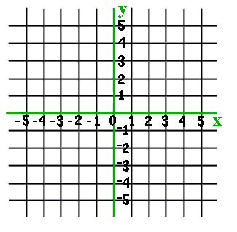24._______________________________ 25. __________________________________



26.________________________________ 27. _________________________________

28. Which equation has a slope of ½ and a y-intercept of 8?

A. y= ½ x + 8 B. y=8x+ ½ C. y=- ½ x + 8

**Complete** the X-Y charts for each equation. **Plot** the points and **graph** **two** lines, or use the slope and y-intercept to graph the line.

29. y= ½ x + 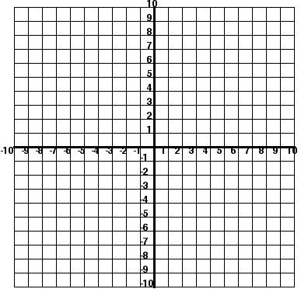3

|  |  |
| --- | --- |
| **x** | **y** |
| 0 |  |
| 2 |  |
| 4 |  |

y=x-1

|  |  |
| --- | --- |
| **x** | **y** |
| 0 |  |
| 2 |  |
| 8 |  |



30. 31.

How many solutions?_____________ How many solutions?______________

32. What kind of lines will have an infinite number of solutions?______________________________

33. Cody mows lawns to earn spending money. He gets paid $18 per lawn. Write an equation to calculate his total pay for up to 10 lawns. Define the two variables. Create a graph showing his total pay. What are your variables?

__=_____________________________

__=_____________________________

b. Write an equation using both variables and the information given in the problem.

____________________=____

c. Make an input/output chart for your two variables.

equation____________________

d. Graph your data.



34. Kyle charges a $50 painting fee as well as $8 an hour. Which equation represents the total cost (T) in relation

to hours worked (H)?

A. T+H=58 . T=8H+50 C. T=50H+8

**Directions:** Circle the best answer and print the letter of your answer choice on the line provided.

35. _____The slope-intercept form of a linear equation is:

A. x + y = 6

B. y = mx + b

36. How many equations are involved in a system of equations?

A. one

B. two

C. three

37. _____The solution to a system of equations is the single ordered pair that works in both equations.

A. true

B. false

38._____What is the solution to the system of equations: y=9x-9 & y=9?

A. (9, 2)

B. (2, 9)

39._____Slope is defined as the direction and steepness of a line.

A. true

B. false

40._____The y-intercept is the point at which a line crosses or hits the_________.

A. x-axis

B. y-axis

41. ______ Which line has a negative slope?

A. B.

42.______ For this systems of equations: 2x + 6y = 68 & y = -2x + 8

If y = 12, what value does x equal?

A. -2

B. 2

43.______ Which point is a solution for this system of equation:

3x + 5y = 7 y = -4x + 15

A. (0, 3)

B. (4, -1)

44.____­­__How many solutions does this system of equations have?

A. one solution

B. no solutions

C. infinite solutions

45.______How many solutions does this system of equations have?

A. one solution

B. no solutions

C. infinite solutions

46.______What is the solution 47.______What is the solution to

to the system of equations the system of equations graphed

graphed below? below?

 

A. (2, 0) B. (0, -1) A. (0, 0) B. (1, 1)

48. _____How many solutions do identical lines have?

A. no solutions

B. infinite solutions

49._____What is the y-intercept (b) of the following equation? y = x - 3

A. 1

B. -3

BONUS (3 points) Solve the equation for x.

2x-4=16

50. Solve the system of equations using the “circle of life.” Write your answer in the form of an

Almost done…..

ordered pair (x, y). y=2x+5 y=4

51. Solve the system of equations by graphing. Write the solution in the form of an ordered pair (x, y).

y=2x-5 x+y=4

Solution:(______)

Turn in your quiz and relax!