Graph the line for each equation.
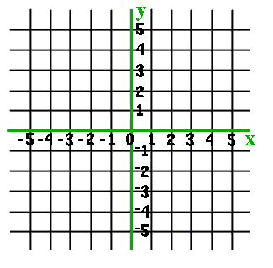
1. y=1/2x+2 2. y=4x-2
3. y=-1/3x-1 4. y=-3x+4

Turn the page, please.

5. y=1/5-4 6. y=-4x
7. y=-1 8. Draw a line. Write the equation.
__________________________

