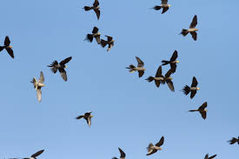
¼ of the bird population in your town is 200 birds. How many birds live in Louisville?

