Complete the X-Y charts. Graph the equations.
x + y = 6 y = ½ x + 2
x y x y
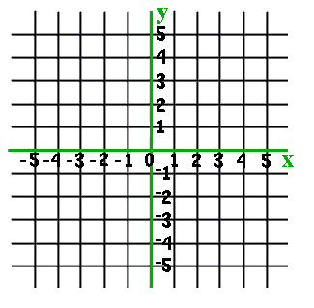
1 ___+y=6 0 y= ½*__+2
3 ___+y=6 2 y= ½*__+2
5 ___+y=6 4 y= ½ *__+2

