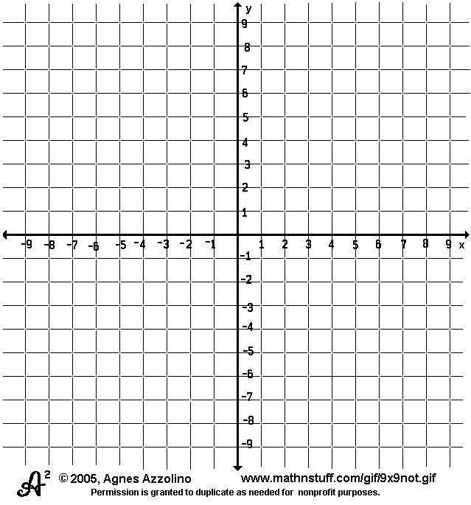
1. Reflect rectangle ABCD across the
x-axis. Label rectangle A’B’C’D’.
List the coordinates of the prime
points below.

A’ ( )

B’ ( )

C’ ( )

D’ ( )

2. Translate parallelogram GHIJ
right 2 units and up 3 units.
Label parallelogram G’H’I’J’. List the
coordinates of the prime points
below.

G’ ( )

H’ ( )

I’ ( )

J’( )

3. What does not change when a
figure is translated?

