Directions: Circle the outlier for each data set and graph.
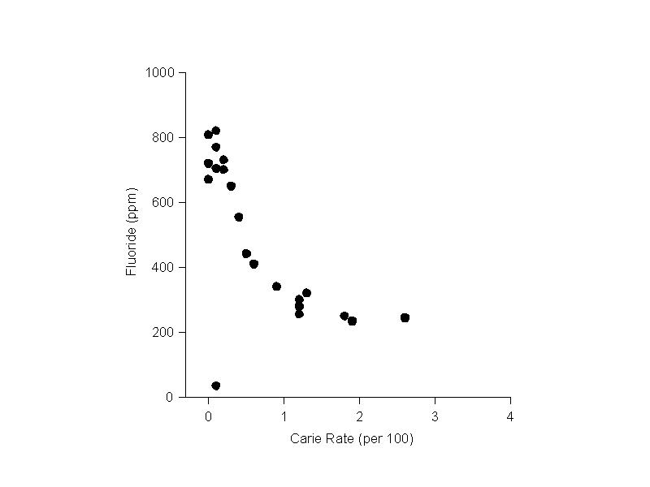
1.

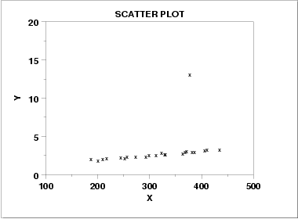
2.

3. 15, 75, 20, 35, 25, 85, 30, 30, 15, 25, 30

4. 212, 361, 201, 203, 227, 221, 188, 192, 198

