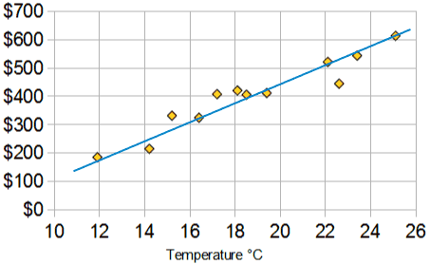
What is a line of best fit?

The purpose of a line of best fit is to ________________________________________________
_____________________________________________________________________________.

