_____1. For this parallelogram, set up an **equation**, then **solve for the x**. Show your work in the space provided.

**A.** x=14 degrees **B.** x=94 degrees

_____2. What is the solution for the following system of equations: T = 100 + 20B and T = 200?

**A.** (5, 200) **B.** (80, 200)

_____3. What is the slope of the line segment below?

**A.** undefined **B.** 0

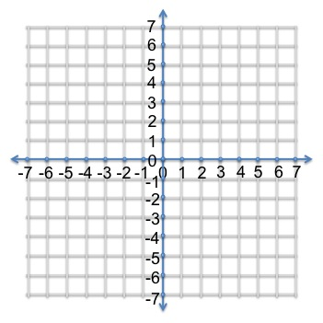

_____4. What is the slope of the line that goes through the points (-6, 2) and (-3,8)? (Hint: plot on a grid) **A.** ½ **B.** 2

_____5. What is the solution for the system of equations graphed below?

**A.**  (4, 2) **B.**  (-4, 2) 